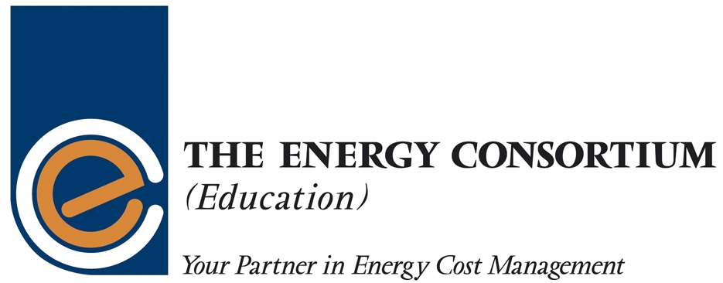

Your Invitation to the:

The Energy Consortium

Annual Conference 2007

November 6th, Burlington Hotel, Birmingham

“SUSTAINABLE FOCUS”

Our Conference this year will focus on a number of aspects of sustainability affecting the Higher and Further Education sectors. Delegates will have the opportunity to be informed by key players including the Carbon Trust, EAUC in the areas of sustainability in general but there will be practical solutions to sustainability on campus and the usage of energy in our institutions. The afternoon workshop session will give delegates the opportunity to discuss relevant practical ‘on campus’ solutions to sustainable building issues, the use of Automated Meter Readers (AMRs) and wider sustainability within the Higher and Further Education sectors. Conference sessions and workshops will address the sustainability agenda and how it applies to our market and the many ways we use energy in support of our strategic and operational objectives.

Experience tells us that effective working relationships in the energy market work best when both parties to any deal have mutual respect for each other, respect based upon knowledge of the sector and industry, and professionalism in the way procurement is handled. Sustainability is not just about green issues but is concerned with building up long term sustainable working relationships and our event will demonstrate to delegates just how this can be most effectively achieved.

The theme of our conference impacts on the entire HE and FE sectors – everything we do can be related to some aspect of energy management – from procurement, to its usage in the delivery of our core businesses. How to achieve all this and do it sustainably will be of interest to everyone in our sectors.

If you have any responsibility for any element of this supply and delivery chain then you are encouraged to attend. Regardless of the size and complexity of your estate, we know you will leave our conference with a clear understanding of the issues in sustainable energy management and you will also leave with a wealth of practical examples of how you can make a real difference to the learning and working environments in your institutions at a cost that will please everybody.

As a ‘Not for Profit’ organisation, the Energy Consortium is delivering your conference at very competitive delegate rates and we look forward to your booking and welcoming you to the Burlington Hotel on the 6th of November.



