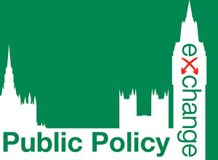 | Protecting British Pollinators: Halting the Decline of Bee Populations and Addressing Serious Threats to Biodiversity  Thursday, March 10th 2022

Delegate Fees
Number | Public Sector, Not-for-Profit, NGOs and Academic Delegates | Private Sector Delegates
1Place | STANDARD RATE:£99 | STANDARD RATE: £249
2+Places | STANDARD RATE:£89 | STANDARD RATE: £229

Delegate Details
Delegate Name | Position | Email Address
1
2.
3.

Key Contact Details Invoice Details
Name:  Organisation:  Department:  Address:  Telephone:  Email:  Invoice details are the same as Key Contact Details | Name:  Organisation:  Department:  Address:  Telephone:  Email:  Purchase Order No. (if applicable):

Method of Payment
I will pay £ + VAT by GPC / Credit Card (Please contact me to obtain card details)
Please invoice my organisation for £ + VAT (at 20%)

Confirmation
Invoices are dispatched immediately upon receipt of the registration form, and payment must be made immediately upon receipt of the invoice. If, for any reason, you are unable to attend the event, a replacement delegate may be sent. On the occasion where no replacement delegate can attend on your behalf, Public Policy Exchange will provide a paid credit for use against a future event which will be valid for 12 months from the event original date. Public Policy Exchange reserves the right to change the date and / or venue of the event.
For full ‘Terms and Conditions’ & ‘Privacy Policy’ please visit; www.publicpolicyexchange.co.uk/terms-and-conditions
I accept the terms and conditions and privacy notice I would like to receive information about similar events
Signed: Date:

PLEASE EMAIL BACK TO jdoorgunah@parlistudies.org

