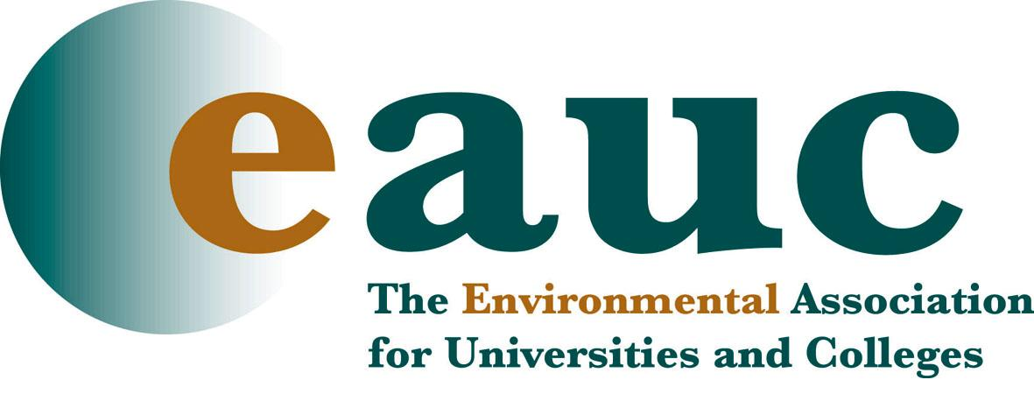

From Net Impact to Net Positive
True Sustainability in Further and Higher Education

QUEEN’S UNIVERSITY BELFAST

Room: G9

Lanyon Building

www.qub.ac.uk/home/media/Media,80594,en.pdf

Friday 15th April 2011

Objectives
- Introduce the Environmental Association for Universities and colleges
- Develop a shared understanding of what a NetPostive institution and NetPostive Leadership looks like
- Explore the role of colleagues and students in making sustainability happen within your institution
- Develop your plans for taking sustainability forward within your institution
- Network with colleagues who are on the same journey

10.30 Registration and refreshments

10.45 Welcome and Introductions – Frasier Lovie

11.00 Unpacking the terminology – What do we really mean by sustainability within a leaning institution?

12.00 What does a sustainable institution look like?

12.40 Coffee Break

13.20 People – the key to success!

14.05 Making it happen – Taking it forward

14.50 NetPositive Sustainability – the leadership dimension

15.35 Launching EAUC – Andrew Chamberlain

15.50 Close

