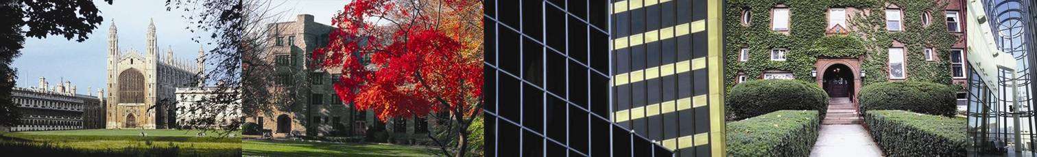
Higher Education Environmental Performance Improvement (HEEPI)

Financing Energy and Environmental Improvement
Sponsored by Salix Finance

June 22 2007, UCL, Gower Street, London

A HEEPI workshop in association with BUFDG and EAUC

Energy efficiency is an imperative, not an option. It is being driven by increased incentive-based regulation (which create penalties for poor performance, but rewards for improvement), rising utilities costs, and growing student and stakeholder pressure. Universities and colleges which respond positively and proactively to these measures will significantly reduce costs and enhance their reputation.

Many actions require capital investment, either in completely new projects, or in incremental spend to substitute greener options for conventional ones. Although the latter are often economic, capital rationing prevents them happening.

This event will highlight existing, and stimulate new, means of overcoming this barrier by:
- Identifying current, and possible future, external sources of funding
- Demonstrating (from experience at Edinburgh, Leeds and other institutions) how good financial cases can be made to internal and external funders
- Considering mechanisms such as ‘ring fenced’ budgets and whole life costing.




The event will be of interest to finance directors, energy and environmental managers, and others within higher and further education, as well as external bodies such as commercial lenders, RDAs and others with an interest in supporting HE and FE environmental improvement initiatives.


Financing Energy and

Environmental Improvement

June 22 2007, UCL, London

Draft Programme

10.00 – 10.30 Registration & Coffee

10.30 – 10.35 Welcome & Introduction
10.35 – 10.50 Overview – Why Higher Education Needs To Do More and How Current Financial Barriers Might Be Overcome
Prof. Peter James, Co-Director, HEEPI

10.50 – 11.40 Current UK Solutions – Carbon Trust and Salix Finance
Alastair Keir, Director of Operations, Salix Finance

11.50 – 12.20 Current UK Solutions – The Edinburgh Experience
David Somervell, Energy & Sustainability Manager, University of Edinburgh (a recent recipient of Salix funding, which it is matching within a ring-fenced budget)

12.30 – 13.30 Lunch

13.30 – 14.00 Current UK Solutions – The Leeds Experience
Keith Pitcher, Environmental Manager, University of Leeds

14:10 – 15.00 US Solutions – Harvard’s Green Campus Initiative
Leith Sharp, Director, HGCI

15.10 – 16.00 Ways Forward – Panel Discussion
Panel of speakers, and others

16.00 (approx) End

To book a place please email Fiona Goodwin at events@heepi.org.uk including details of any particular dietary requirements.

