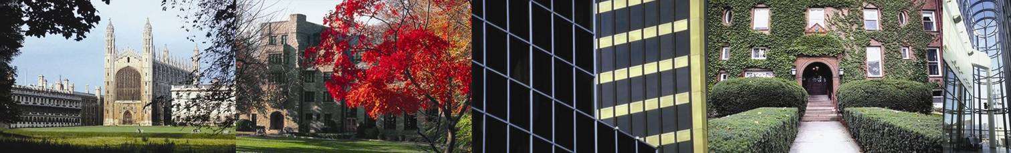
An Event Organised by EAUC Scotland, Scotland North East JISC Regional Support Centre and SusteIT

Implementing Green IT

Cutting ICT-related Costs and Carbon

Queen Margaret University, Edinburgh Musselburgh Campus, August 24 1200-1630

Colleges and universities are increasingly aware that they need to minimise their ICT-related energy consumption and environmental footprint – a message which was reinforced at a recent JISC Regional Support Centre Smarter Greener Learning event. This follow on, free, conference focuses on the implementation of green IT and can be booked here. It is a partnership of EAUC Scotland’s Scottish Funding Council-financed Carbon and Energy Management Programme; and two JISC-supported bodies, the Scotland North East RSC and the SusteIT project. Topics to be addressed include:

- Identifying cost-effective and easily achieved improvement opportunities
- Persuading managers and colleagues that Green IT is feasible and worthwhile
- How automatic powerdown can payback in a few months
- Effective implementation of virtualisation
- More efficient data centre cooling through conventional methods, free cooling and direct use of chilled water
- Raising the desktop bar through the new Energy Star 5 scheme.

Book here, and visit here for venue location.






Implementing Green IT

QMU, Edinburgh, August 24, 12:00-16:30

12.00 – 12.45 Registration and lunch (sponsored by Bull)

13.00 – 13.05 Welcome and Introduction
Sarah Price, Director, JISC Scotland North East RSC

13.05 – 13.30 How to cut sector IT energy bills by at least 10%
Andrew Chamberlain, Scotland Manager, EAUC and Professor Peter James, Director, SusteIT

13.30 – 14.10 Case study - Reducing IT energy through water cooled data centres, powerdown, thin client and virtualisation
Scott Walkingshaw, Infrastructure Systems Team Leader, Edinburgh Napier University

14.10 – 14.50 Case study – How Norwich CC has reduced IT energy through powerdown, virtualisation and other measures John Pollitt, IT Manager, Norwich City College

14.50 – 15.10 Refreshments

15.10 – 15.50 Case study - Understanding your IT energy and carbon footprint, and taking action to reduce it
John Clayton, Angus College

15.50 – 16.30 Panel discussion – Persuading management and technical colleagues to take action
Panelists tbc

16.30 (approx) End

